BIFID programs.

There are two programs in this folder.

The first program is called Bifid_drag_crib.py, which is a python program. It finds the correct crib position and gives you the relationships. To run it you need first to have downloaded python from
http://www.python.org/download/

and installed it on your computer. Then put the program Bifid_drag_crib in the Python folder, start Python and run the program.

Before you run it, paste the Bifid ciphertext into the program where shown and also type in the period.

Alternatively you may like to use this program as a reference for writing your own.

The second program is called Bifid_Interactive_Solver which you can download onto your Windows desktop where it will appear as an icon:

Double-click on the icon and this form will appear on your screen:

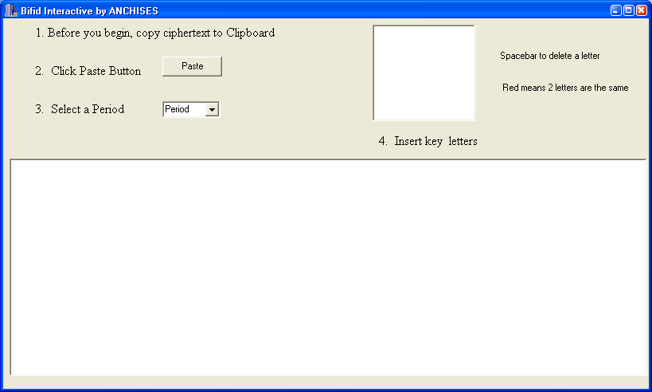

Follow the instructions on the form.

(1) Copy the ciphertext to your clipboard. For example copy this:
LCNLYUH ENFRPUD NRKEWMI RIMVBTS RPRQAAE NRQRXML IGKDTZW ALGGDCP BOVALWP NRKAYYE BRFLOCN ORKVTAW WRRVETE LNNIBTF ROLATED OLRSDWA NVBITQL TGLVOWZ WCPFYZC RPFQMGZ

(2) Click the Paste button and you get:

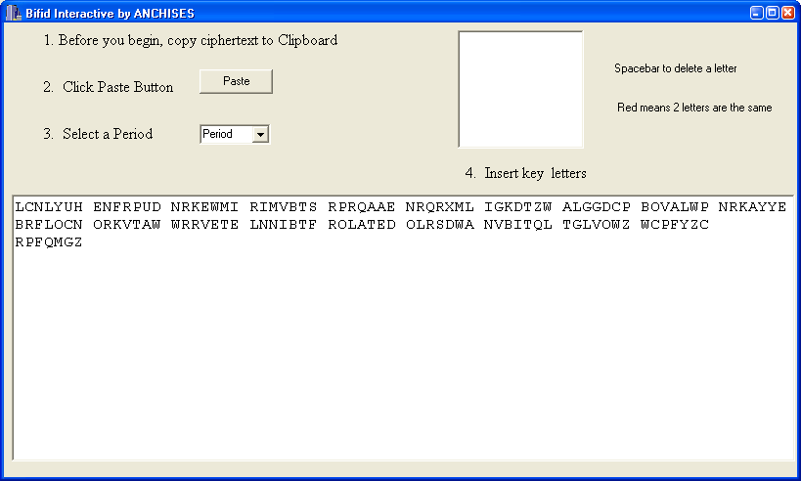

(3) Now enter the period which is 7. Click the little arrow in the period box. You get a drop down box with a series of numbers. Click 7 and you get:

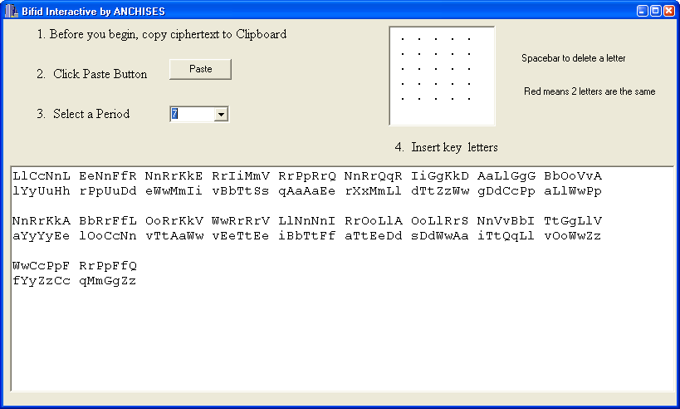

Now the interactive part begins. You guess key letters and type them into the 5x5 box – clicking on a dot and then typing a letter. Use the recovered relationships to guide you. So you might set out:

